CONFIRMATION PLAN

All,
Our normal Confirmation schedule is obviously postponed due to Covid restrictions. Therefore, the new plan is below. If everyone in the program completes the requirements, then he or she will be confirmed on May 23, 2021 (Pentecost Sunday). Each month has designated assignments, and some have alternative choices as well. Please complete these by the end of the month. We may also try to gather occasionally if it works out. I ask that parents/family members participate where possible. This is about sharing and growing in faith, not schoolwork. I pray for each of you. Please let me know if you ever have questions or need assistance with this program. Send all work to Pastor Jeff by email unless stated otherwise.

OCTOBER (The Reformation)

Go to the link below and view the video

“Who Was Martin Luther? 95 Theses & The Reformation | World History (1517)”
https://www.youtube.com/watch?v=kKQWNgjdS9Q
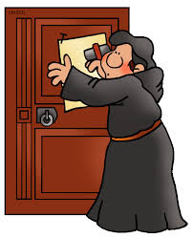
Write a short summary using bullet points on what you learned. Be sure to give at least 5 points and be specific with each one. Name names and list specific facts: Consider these 3 questions as you summarize:
- Why did Martin Luther nail 95 Theses (points of debate) to a door?
- What invention helped Martin Luther spread his ideas?
- Why was it called “The Protestant Reformation?”

- Begin searching for a Bible verse that will encourage your future self to remember your faith. You have until May to decide.
- In a paragraph of at least 4-5 sentences, summarize what you heard in a worship service this month (live or recorded). Can include the sermon, readings, prayers, or even music.

NOVEMBER (The Eucharist)
- “All Saints Sunday” is a powerful festival of the Church. Research/explore this using your parents, Google, books, etc. and tell me what you learn in any way that inspires you (draw a picture, write a paragraph, take some photos, etc.).
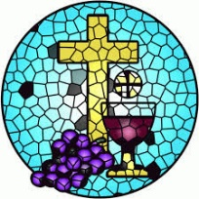
- “Eucharist” means Thanksgiving, so every time we celebrate Holy Communion or “The Eucharist” we give thanks for Jesus dying and rising for us. Schedule a time with Pastor Jeff to help set up and serve communion on a Sunday morning. A parent must accompany you.

DECEMBER (Advent/Christmas)
- Create an Advent Wreath/or Advent Calendar in any fashion you want. Can be as simple as a drawing or a full-on wreath with candles. But you must be able to interact with it by “lighting” a new candle each week. For example, if you do a drawing, each week you need to add a flame to one of the candles in the drawing. Send a pic of your creation to Pastor Jeff. This is best done in late November or early December.
- Find the Christmas Story in all four Gospels (Matthew, Mark, Luke, and John) and summarize what you find. You can write it, draw a picture, or record yourself talking about it with your family of to the camera. Hint there is a trick question here. See if you can figure it out.
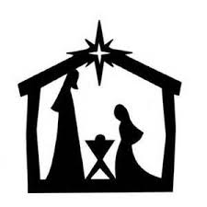
- In a paragraph of at least 4-5 sentences, summarize what you heard in an Advent worship service this month. Can include the sermon, readings, prayers, or even music.

JANUARY (Epiphany)
- Shine the Light! January 6th is the Day of Epiphany, the end of the 12 days of Christmas where we hear about the “wisemen” following the star to find the newborn king. God shined the light to help us find Jesus. Create a service project to do with your friends or family “In the name of Christ” to shine some of God’s light. Work at a soup kitchen, read some Bible stories to children on a video to send out, collect food for Crisis Assistance Ministry, etc. Tell me what you end up doing and tell me how it served God’s purpose. Please do not use a civic club event to “double up.”
- Continue searching for a Bible verse that will encourage your future self to remember your faith. You have until May to decide.
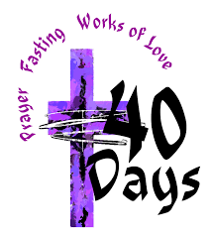
FEBRUARY (Lent)

- Make a plan for observing Lent that includes, reading scripture, prayer, and acts of love. Keep it simple. Let me know what you come up with.
- Attend Ash Wednesday service (optional but highly encouraged)
- In a paragraph of at least 4-5 sentences, summarize what you heard in a Lenten worship service this month. Can include the sermon, readings, prayers, or even music (live or recorded).

MARCH (Time after Pentecost)- This is normally in the summer but wanted to have the other church seasons in the actual month they occur).
- The focus in the “Green Season” is about growth. Think about growing trees, flowers, animals etc. in the summertime. The color for St. Patrick’s Day is green. St. Patrick was a priest who helped the people of Ireland grow as followers of Jesus. He used simple things like a clover to talk about the Trinity (Father, Son and Holy Spirit). Discuss with a family member or friend, how the small catechism (the simple book Luther wrote) can be used to help you grow in your faith. Take some time with this. May be more than one discussion. Find a way to report back to me what you discovered.

APRIL (Easter)
- Easter proclaims that God has power over death and all things, and that God loves us and claims us despite our mistakes. This is the most important news we will ever receive. Our baptism and Holy Communion are a reminder of that. Come up with a way to remember your baptism during the week when you are not at church. What are you going to do and explain why it is important to be reminded of the “Easter Promise?” Use any format to show Pastor Jeff
- Attend Easter Sunday service (optional but highly encouraged)
- In a paragraph of at least 4-5 sentences, summarize what you heard during the Easter Sunday worship service (live or recorded). Can include the sermon, readings, prayers, or even music.

MAY (Pentecost)
- Give your verse to Pastor Jeff that you will use to encourage your future self in the faith
- Pentecost Sunday is May 23. This is Confirmation Sunday. Please put this on your calendar. Please dress nicely. The Bible verse you picked will be read at this service. Pastor Jeff will give you more details in May.

June (Camp)
Summer camp at Lutheridge- This is optional but highly recommended. The dates are June 13-19. Redeemer will cover half the cost which is around $500 total. Please give this some serious thought. It is a wonderful week!
